SHPC Preschool Parents Calendar 2021-2022
Welcome! The following is a calendar for our 2021-2022 school year. All dates are subject to change,
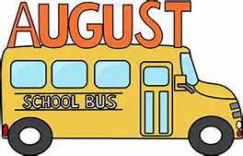
Monday, 30 FIRST DAY OF SCHOOL FOR STUDENTS!
Parent Meeting @ 9:15am: Meet with the Director to discuss school philosophy, activities, policies and procedures, and any questions you may have. All parents are encouraged to attend.
Monday, 6 Labor Day: NO SCHOOL
Monday, 13-17 Apple Week: all classes enjoy learning, tasting, and creating with apples!
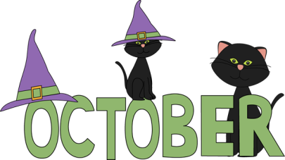
Monday, 4 Pre-K Students begin homework packets.
Wednesday, 27 Orange Day the first of our monthly “Color Days” where our students and teachers wear the selected color and the school builds the curriculum to reinforce identification in the world around us. All classes will carve pumpkins to be displayed at our Halloween Parade of Costumes.
Friday, 29 Halloween Costume Parade: Students come to school in their Halloween costumes and parents and family are invited to join us in the yard for a parade of costumes and our first preschool performance. After, parents join students in their classrooms to change them into play clothes and the rest of the day resumes. We will also have a sign-up sheet if you would like to bring special treats for snack.
Monday, 8-12 Classes will make pumpkin bread and or muffins
Thursday, 11 Veterans Day: NO SCHOOL
Wednesday, 17 Yellow Day
Tuesday, 23 Classes will make Friendship Soup.
Wednesday, 24 Thanksgiving Feast: Each class will work together to prepare and share a Thanksgiving feast. NO EXTENDED
Thursday, 25 NO SCHOOL Happy Thanksgiving!
Friday, 26 NO SCHOOL

Monday,13 Making Reindeer Food
Wednesday, 15 Christmas Program: 11:15 in the Sanctuary. (NO EXTENDED)
Friday, 17 Special Snack , a sign-up sheet will be posted if you would like to bring a special snack.
Monday, 20-3 Christmas Break
Saturday, 25 Merry Christmas

Saturday, 1 Happy New Year
Monday, 3 School resumes
Monday, 17 Martin Luther King Day: NO SCHOOL
Friday, 21 Pajama Day: Students and teachers wear their pajamas to school and snack will be breakfast fare.
Wednesday, 26 Blue Day
Wednesday, 9 Kinder-readiness Meeting: Parents are invited to meet with the Director to discuss useful information in visiting and choosing a kindergarten and the developmental milestones targeted for greatest success. Tentative
Monday, 14 Valentine's Day Card Exchange. A sign-up sheet will be posted if you would like to bring a special snack.
Monday, 21 President's Day: NO SCHOOL
Wednesday, 23 Red/Pink Day
Wednesday, 2 Silly Hat Day: Families are encouraged to get creative and make a fantastic hat together at home and wear it to school. Happy Birthday Dr. Seuss.
Thursday, 17 Green Day, St. Patrick’s Day: We will be cooking/serving “Green Eggs and Ham”
Monday, 21 Trike-A-Thon Licenses: Students will ride a practice course in preparation of our Trike-A-Thon. Licenses will be issued showing that they are ready for the big day.
Friday, 25 Annual Trike-A-Thon Fundraiser: A fun day with family participation. NO EXTENDED

Friday, 8 We will be dying Easter eggs. Special snack, a sign-up sheet will be posted if you would like to bring a special snack.
Monday, 11-19 Spring Break
Sunday, 17 Happy Easter
Monday, 18 Staff Development Day. NO SCHOOL
Wednesday, 27 Purple Day

Thursday, 28 School Pictures, Information will be sent home Tentative
Friday, 29 School Pictures, Information will be sent home Tentative

Sunday, 8 Happy Mothers Day.
Wednesday, 11 Open House set up: NO EXTENDED
Thursday, 12 OPEN HOUSE @ 7pm. NO SCHOOL
Sunday, 9 Happy Mother's Day!
Friday, 20 Teddy Bear Picnic: Students bring their teddy bears (or favorite stuffed toy) to school for a school-wide picnic at snack time. (special snack will be provided)
Monday, 30 Memorial Day: NO SCHOOL

Wednesday, 1 Pre-K Graduation @ 11:15am
Friday, 3 FINAL DAY OF SCHOOL: End of year party. A sign in sheet will be posted if you would like to bring a special snack.
Sunday, 19 Happy Father’s Day
Monday, 20 Summer Program begins.

Remember all dates subject to change or be canceled

